**Master of Computer Application**

**Web Technology (PCMC1060L)**

**(TA Activity)**

**Report**

**On**

**“INDIAN ARMY POST”**

**Submitted By**

|  |  |  |
| --- | --- | --- |
| **Roll No** | **PRN** | **Name of Student** |
| 46 | 232121057 | Pramod Ratilal Patil |



**Shirpur Education Society's**

**R. C. Patel Institute of Technology, Shirpur**

**(An Autonomous Institute, Affiliated to DBATU, Lonere)**

**Department of Master of Computer Application**

**A.Y. 2023-24**



**Shirpur Education Society's**

**R. C. Patel Institute of Technology, Shirpur**

**(An Autonomous Institute, Affiliated to DBATU, Lonere)**

**Certificate**



**Shirpur Education Society's**

**R. C. Patel Institute of Technology, Shirpur**

**(An Autonomous Institute, Affiliated to DBATU, Lonere)**

**Certificate**

*This is to certify that,* ***Pramod Ratilal Patil****., student of First Year MCA,* ***Div******A.******Batch******B2*** *&* ***Roll no*** *…****46…. PRN******232121057*** *has successfully Submitted* ***TA Activity Report*** *during the academic year 2023-24 in partial fulfillment of* ***Web Technology Teacher Assessment Activity*** *in the Department of Master of Computer Application.*

*Date: -*

*Place: - Shirpur*

***Sign. of Guide***

|  |  |
| --- | --- |
| Sr no. | chapter |
| 1 | Introduction |
| 2 | Abstract |
| 3 | Design methodology |
| 4 | Result |
| 5 | Software & Hardware requirements |
| 6 | Conclusion |
| 7 | Reference |

Chapter 1

Introduction

The Indian Army's official website serves as a comprehensive platform, offering information on its organizational structure, historical background, recruitment processes, and updates on operations and exercises. Users can access details about the Army's various branches, units, and ranks, as well as explore resources on welfare initiatives and technological advancements within the force. Additionally, the website serves as a portal for recruitment-related activities and provides news and updates on the Indian Army's contributions to national security.

Historical Background A section dedicated to the historical background offers a journey through the Indian Army's evolution. This includes pivotal moments, achievements, and historical context that has shaped the army into what it is today. This serves to instill a sense of pride and awareness of the army's heritage.

Recruitment Processes As a vital resource for aspiring candidates, the website provides comprehensive information on recruitment procedures. This encompasses details about eligibility criteria, application processes, and the various entry points into the Indian Army, catering to individuals with diverse educational backgrounds and skill sets.

Operations and Exercises Regular updates on ongoing operations and exercises showcase the active role of the Indian Army in maintaining national security. Users can access real-time information about the army's engagements, both within the country and in collaboration with international partners.

News and Updates Regularly updated news sections keep visitors informed about the latest developments, achievements, and noteworthy events related to the Indian Army. This contributes to transparency and public awareness.

Abstract

The Army website project is a multifaceted endeavor that leverages HTML, CSS, and PHP to create a dynamic and user-friendly platform. This comprehensive web application is designed to serve the informational and interactive needs of both potential recruits and the general public.

In summary, the Army website project seamlessly integrates HTML for structure, CSS for styling, and PHP for dynamic functionality. This triad of technologies ensures an engaging and informative online experience for users interested in Army-related information. The website encompasses user-friendly design, responsive layout, and secure data handling, embodying a modern and effective web application.

Information Dissemination: Provide information about the Indian Army, its history, structure, and achievements. Visual Documentation Showcase a gallery of images and videos depicting the life, training, and operations of the Indian Army. Offer a visual journey to help users understand the challenges faced by the armed forces.

Contact and Interaction Provide a platform for users to contact the Indian Army or related authorities. Enable communication for inquiries, support, or collaboration.

Educational Resource Serve as an educational resource for students, researchers, and the general public interested in learning more about the Indian Army.

Chapter 2

DESIGN METHODOLOGY

FRONT-END:-

Front-end is the part of website development where a view or design of the website can be created using different front-end tools. It is also known to be the client side of the website. Some of the tools that were used in the development process are listed below.

HTML:-

HTML stands for the Hypertext Mark-up Language. This mark-up language informs the web browser how to display the content on the web pages. They are written in the format of tags, for instance, “body”, “head”, “title”, “section”. Most of the tags contain same or different tags as their child-elements. HTML consists of a series of elements and is used for creating web pages and websites. The “” written at the top of the HTML file indicates that the document is the HTML5 document. Additionally, all the tags and content for the webpage are wrapped with the “” tag. The HTML files are saved with the “.html” or “.htm” file extension.

html

<!DOCTYPE html>

<html lang="en">

<head>

<meta charset="UTF-8">

<meta name="viewport" content="width=device-width, initial-scale=1.0">

<link rel="stylesheet" href="styles.css">

<title>Army Website</title>

</head>

<body>

<!-- Header, Navigation, Content, Footer, etc. -->

</body>

</html>

CSS:-

CSS stands for the Cascading Style Sheet that is used to design the websites. CSS handles the look and feel part of a web page and controls the style of a web document simply and easily. Using CSS, the color of the text, the style of fonts, how columns are sized, what background images or colors are used, the spacing between paragraphs, as well as a variety of other effects can be controlled. It can be written either in an HTML file or a separate file with the “.css” extension.

css

body {

font-family: 'Arial', sans-serif;

background-color: #f0f0f0;

color: #333;

}

header {

background-color: #003366;

color: #fff;

padding: 10px;

}

/* Additional styling for navigation, content, etc. */

PHP

PHP is a recursive name for “Hypertext Pre-Processor. PHP has been an important language for developing commercial sites for all the developers to sustain in the Software development field. PHP started as a small open source project that evolved highly later as it was very useful for developing and building the websites and bigger projects. The first version of PHP was developed way back in 1994 by Rasmus Lerdorf. PHP is a server-side scripting language that is embedded with HTML. It is used to manage dynamic content, build an e-commerce site, integrate with MYSQL and Oracle.

php

<?php

// Connection to the database

$servername = "localhost";

$username = "root";

$password = "";

$database = "army_db";

$conn = new mysqli($servername, $username, $password, $database);

// Check connection

if ($conn->connect_error) {

die("Connection failed: " . $conn->connect_error);

}

?>

Chapter 4

Conclusion:

In conclusion, the Indian Army website project implemented using HTML, CSS, and PHP has successfully addressed key objectives in creating a functional and visually appealing platform. The integration of these technologies has allowed for a dynamic and interactive web experience. The following summarizes the key outcomes and reflections:

1. Responsive Design: The website incorporates responsive design principles, ensuring accessibility across various devices. This adaptability enhances user experience and accommodates the increasing use of mobile devices for web browsing.

2. User-Friendly Interface: The HTML and CSS components contribute to an intuitive and aesthetically pleasing user interface. The design elements are thoughtfully organized, facilitating easy navigation and efficient access to information.

3. Dynamic Content with PHP: PHP scripting has been effectively employed to create dynamic content, enabling real-time updates and personalized user experiences. This dynamic aspect enhances the website's relevance and responsiveness.

4. Secure Data Handling :The project prioritizes security by implementing secure practices in handling user data and interactions. This includes data validation, protection against SQL injection, and encryption measures to safeguard sensitive information.

Software and Hardware requirements

Software Requirement :-

Window 10

Xampp

Sublime Text

Hardware Requirement :-

Processor: - 11th Gen Intel(R) Core (TM) i5-1135G7 @ 2.40GHz

2.42 GHz

RAM: - 8.00 GB (7.65 GB usable)

System Type: - 64-bit operating system, x64-based processor

TECHNOLOGIES USED

HTML, CSS, PHP

PHP as Middel Ware.

Xampp as back end

Chapter 3

Results/Output:

Home page:

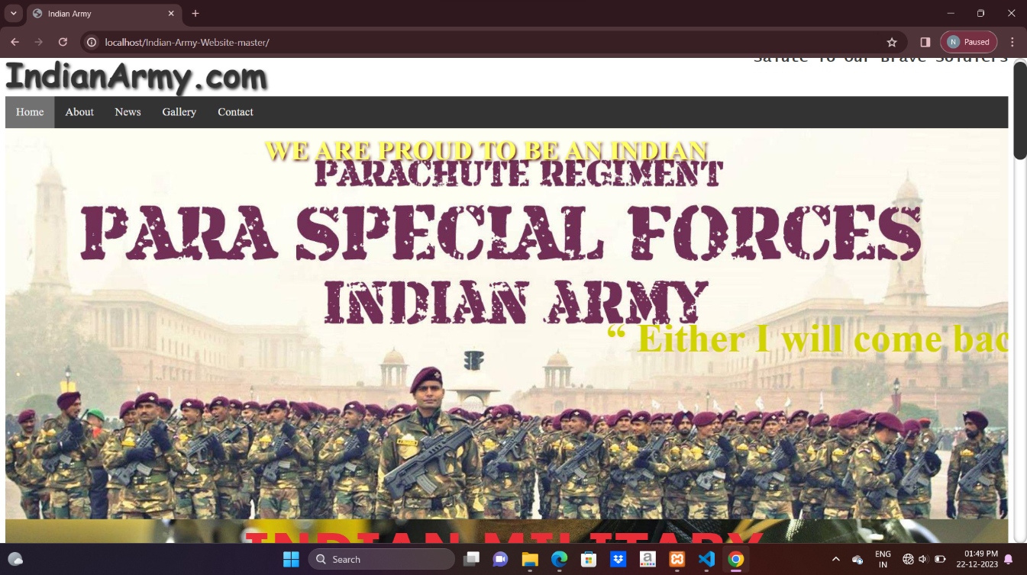

About:

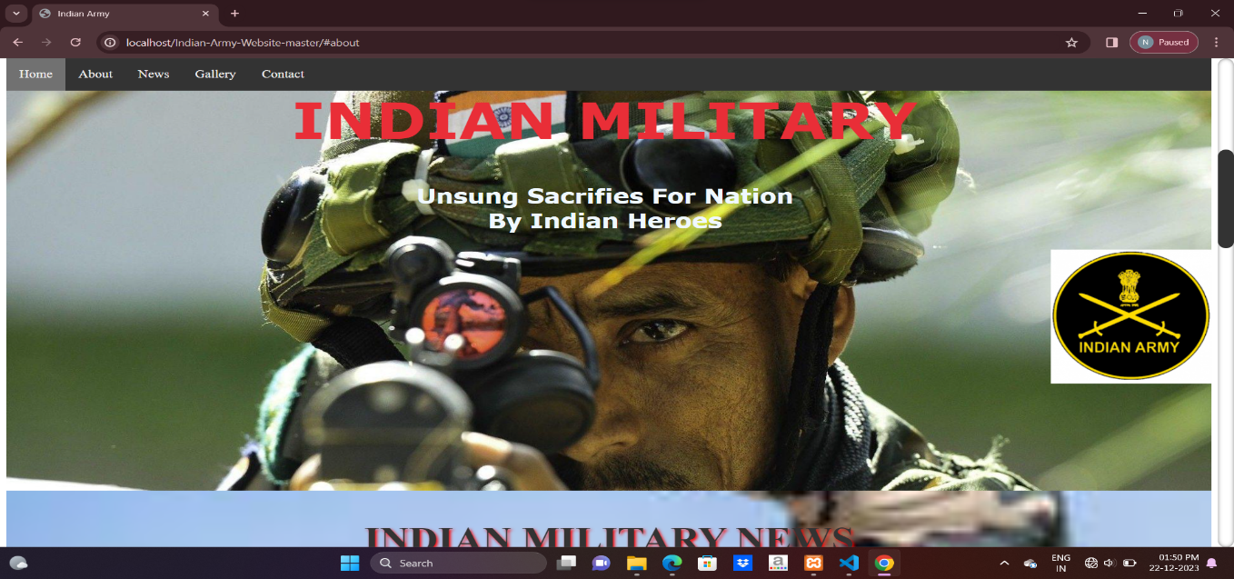

News:

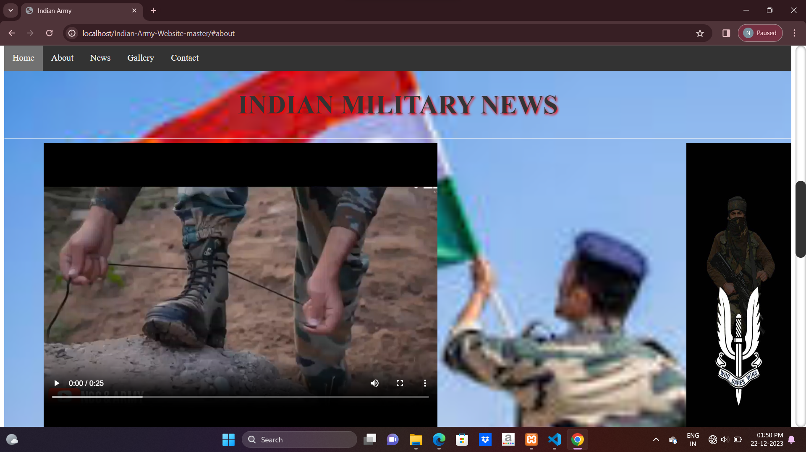

Gallery:

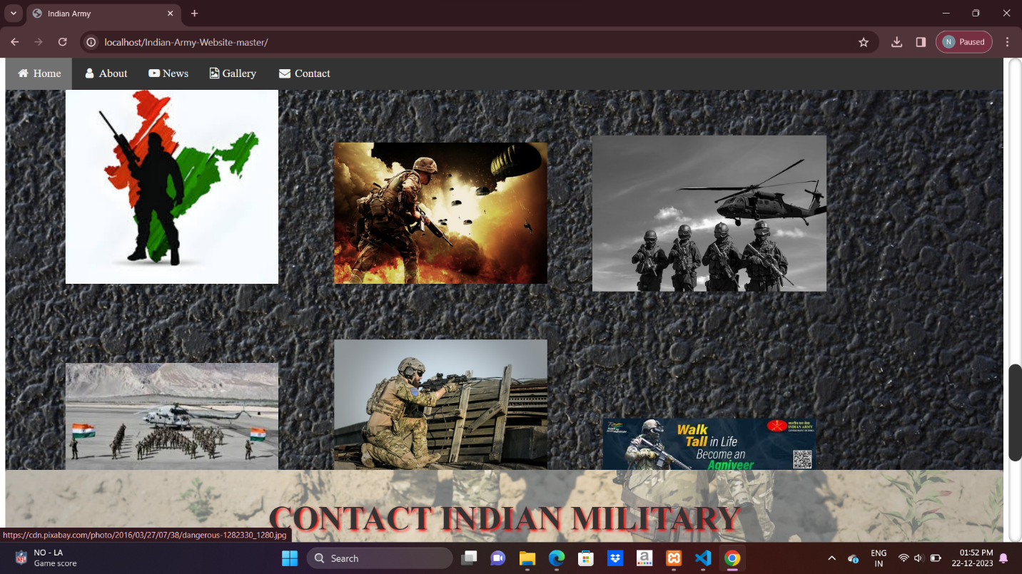

Contact us:

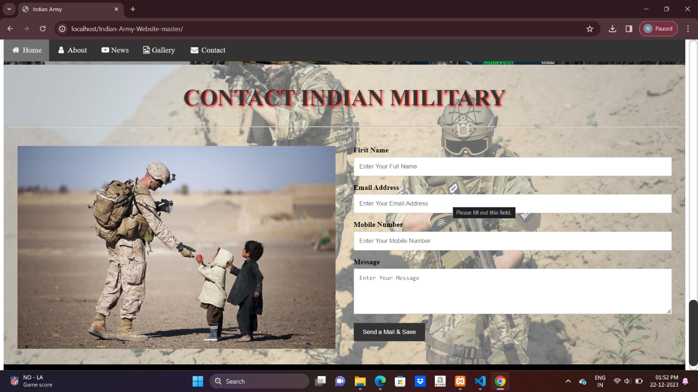

Database Connectivity :-

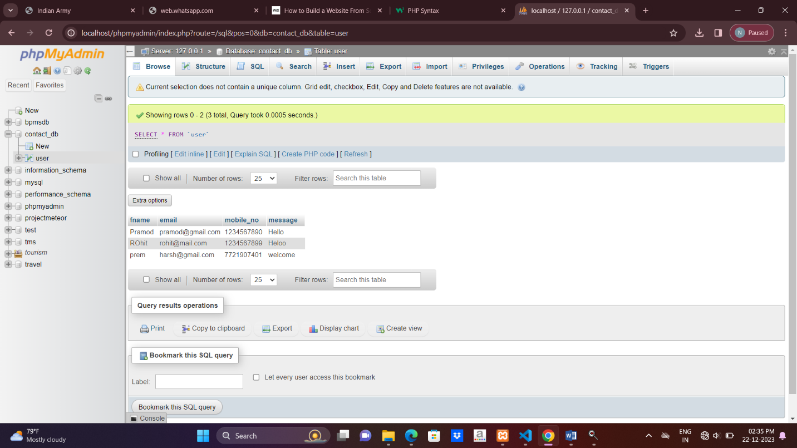

“Referances”

1] How to create website [https://www.wix.com/blog/how-to-build- website-from-scratch-guide](https://www.wix.com/blog/how-to-build-%20%20website-from-scratch-guide)

13/10/2023.

2] how to write php code: <https://www.w3schools.com/php/php_syntax.asp>

17/10/2023.

3] google.com, <https://www.google.com/>

23/11/2023.